REACT APPLICATION NAMED CRICKETAPP

App.js:
import React from "react";
import ListOfPlayers from "./components/ListOfPlayers";
import ScoreBelow70 from "./components/ScoreBelow70";
import OddPlayers from "./components/OddPlayers";
import EvenPlayers from "./components/EvenPlayers";
import ListOfIndianPlayers from "./components/ListOfIndianPlayers";

function App(){
const flag=false;

const players=[
{name:"Lathika", score: 74},
{name:"Lavanyaa", score: 84},
{name:"Madhu", score: 54},
{name:"Manthra", score: 78},
{name:"Monika", score: 85},
{name:"Prathiksha", score: 98},
{name:"Nandhini", score: 76},
];
const T20Players=["First Player","Second Player","Third Player"];
const RanjiTrophyPlayers=["Fourth Player","Fifth Player","Sixth Player"];
const IndianTeam =[...T20Players,...RanjiTrophyPlayers];

return(
<>
{flag===true?(
<div>
<h1>LIST OF PLAYERS</h1>
<ListOfPlayers players={players}/>

<h1>PLAYERS WHO SCORED LESS THAN 70</h1>
<ScoreBelow70 players={players}/>
</div>
):(
<div>
<h1>INDIAN TEAM</h1>
<h2>ODD PLAYERS</h2>
<OddPlayers first="Sachin" third="Virat" fifth="Yuvraj"/>

<h2>EVEN PLAYERS</h2>
<EvenPlayers team={IndianTeam}/>

<h2>LIST OF INDIAN PALYERS MERGED:</h2>
<ListOfIndianPlayers players={IndianTeam}/>
</div>
)}
</>
);
}
export default App;
ListOfPlayers.js:
const ListOfPlayers = ({ players }) => {
return (
<ul>
{players.map((item, index) => (
<li key={index}>Ms. {item.name} <span> {item.score} </span></li>
))}
</ul>
);
};

export default ListOfPlayers;
ScoreBelow70:
const ScoreBelow70 = ({ players }) => {
const players70 = [];
players.map((item) => {
if (item.score <= 70) {
players70.push(item);
}
});

return (
<ul>
{players70.map((item, index) => (
<li key={index}>Mr. {item.name} {item.score}</li>
))}
</ul>
);
};

export default ScoreBelow70;
OddPlayers.js:
export default function OddPlayers({ first, third, fifth }) {
return (
<ul>
<li>First: {first}</li>
<li>Third: {third}</li>
<li>Fifth: {fifth}</li>
</ul>
);
}
EvenPlayers.js:
export default function EvenPlayers({ team }) {
return (
<ul>
<li>Second: {team[1]}</li>
<li>Fourth: {team[3]}</li>
<li>Sixth: {team[5]}</li>
</ul>
);
}
ListOfIndianPlayers.js:
export default function ListOfIndianPlayers({ players }) {
return (
<ul>
{players.map((player, index) => (
<li key={index}>Mr. {player}</li>
))}
</ul>
);
}

OUTPUT:
When flag= true
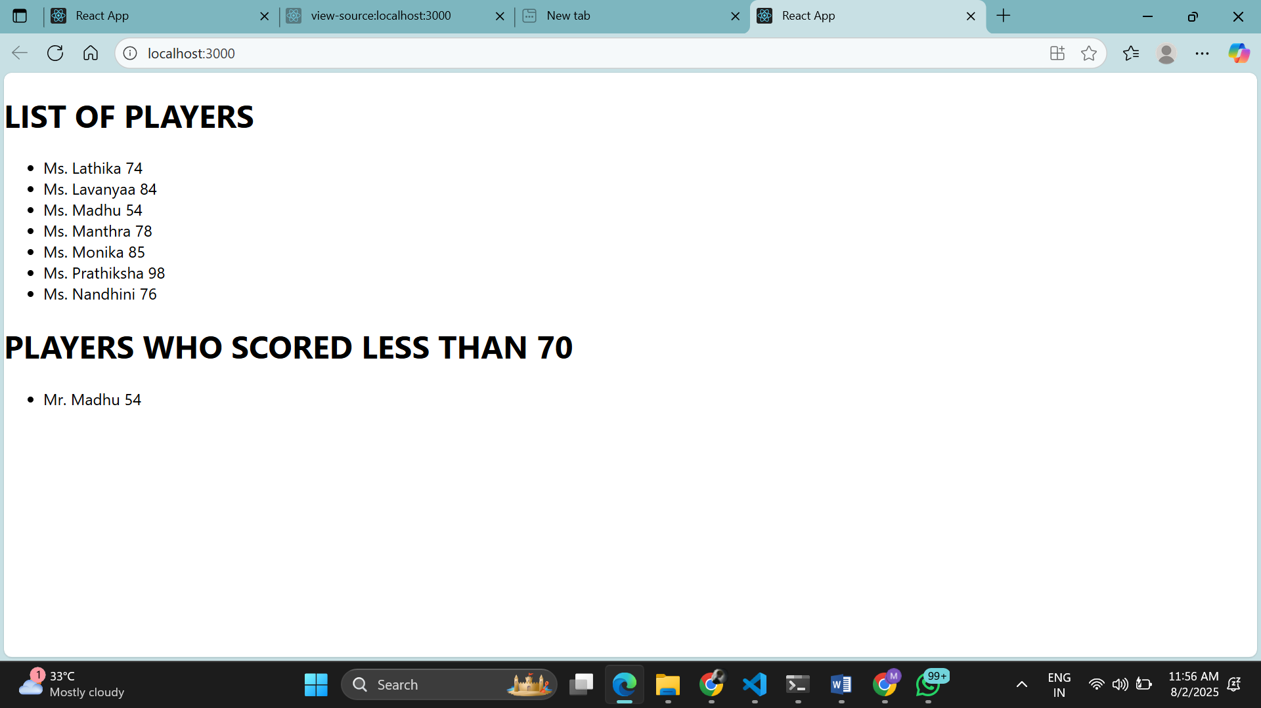

When flag =false
